**Lab 6**

**Speech and Image Processing**

Group assignment up to 3 students per group.

Using MATLAB or Octave, perform the following tasks

**Part (a)** 2 marks

Take a jpeg image and read it in MATLAB using imread() function and display it using imshow() function now convert it to double using double() and again display it using imshow() (note: for double image the color range is from 0 to 1 and not from 0 to 255)

convert this RGB image array into grayscale array “A” and display it

**Part (b)** 3 marks

Now make a small image B as a square sub-image of A

B = A(101:200, 101:200);

Now B is a 100x100 pixel grayscale image. Here the number 101:200 are arbitrary; they can be changed for selecting an interesting portion of image as per requirement (see the three images at the end of document)

**Part (c)** 5 marks

Using for loops, cross-correlate the image A with image B, and the resultant image is saved as C (do not use MATLAB’s built-in cross correlation function. In this new resultant image C, the location on image A which match the template B will have large values, while other places have low values. In this way we can check at which locations a particular object B occurs in an image A.

C[i,j] = $\sum_{u=1}^{100}{}$ $\sum_{v=1}^{100}{}$ A[i+u, j+v] B[u,v]

Remember to subtract the mean grayscale value from the images, so that the pixel grayscale intensities contain both positive and negative numbers).

**Deliverables:** MATLAB code and images A, B and C (images should be unique for all groups)

**Example Images**

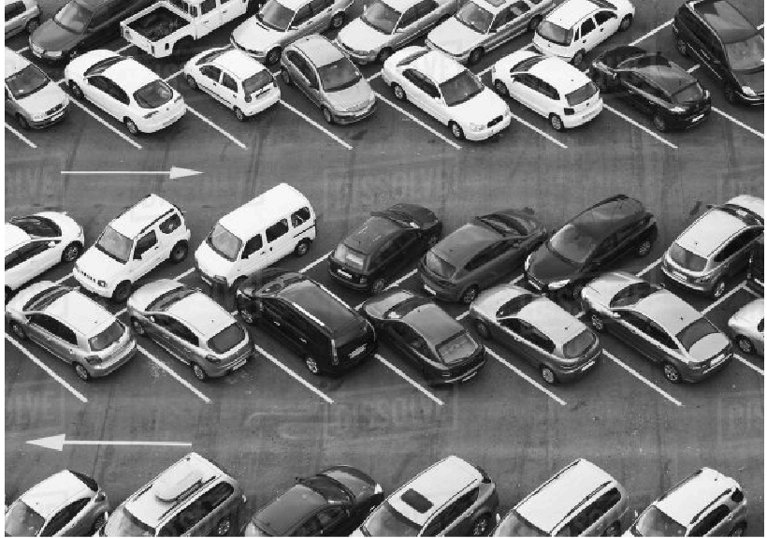

Input image A. 424 x 600 pixels

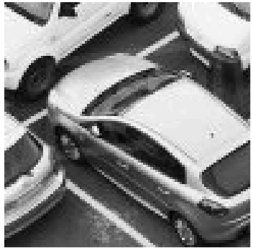

Template image B. 100 x 100 pixels

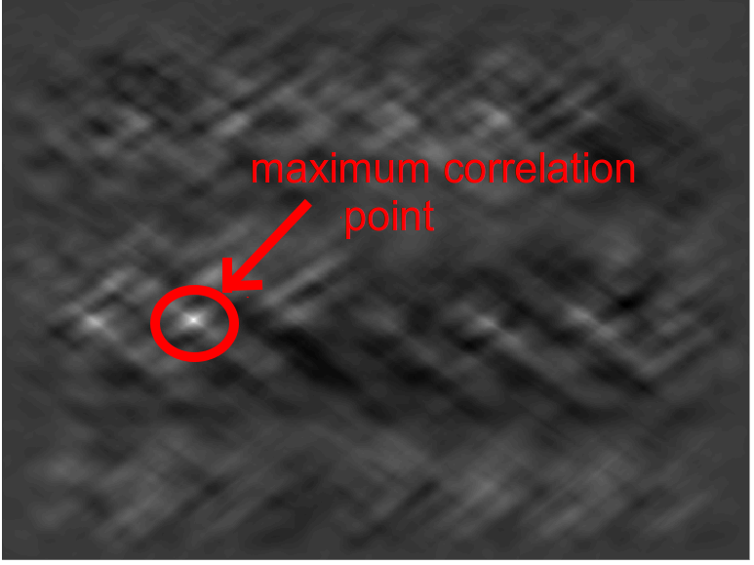

Output image C. Result of correlation which shows the location of template image B inside original image A.